HYPERLINK "https://www.bing.com/images/search?q=skeleton+&view=detailv2&&id=53401EDC915CE4BA86FBB2CAE14ED43BA88B73C3&selectedIndex=64&ccid=BR9aRYsG&simid=608005054901321743&thid=OIP.M051f5a458b06e7b181d52bca28404a14H0" \o "View image details" 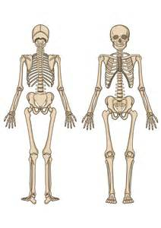
United States Maps

Western |  | Midwest |  | Southern |  | Northeastern
States | Capitals | States | Capitals | States | Capitals | States | Capitals

History Maps

Middle East | Central & Southern Asia |  |  | Far East | Northern Africa |  |  | Tropical Africa | Southern Africa
 |  | British Isles | Western Europe |  |  | Eastern Europe | Australia |  |  | Oceania
Eastern Europe Word Bank

Albania | Estonia | Moldova | Slovakia
Belarus | Hungary | Montenegro | Slovenia
Bosnia Herzegovina | Kosovo | Poland | Turkey
Bulgaria | Latvia | Romania | Ukraine
Czech Republic | Lithuania | Russia
Croatia | Macedonia | Serbia

Tropical Africa Word Bank
Benin | Ghana
Burkina Faso | Guinea
Burundi | Guinea-Bissau
Cameroon | Liberia
Central African Republic | Kenya
Congo | Nigeria
Cote D’Ivoire | Rwanda
Democratic Republic of Congo | Sao Tome & Principe
Djibouti | Senegal
Equitorial Guinea | Sierra Leone
Eritrea | Somalia
Ethiopia | Tanzania
Gabou | Togo
Gambia | Uganda

Central and Southern Asia Word Bank

Afghanistan | Nepal
Bangladesh | Pakistan
Bhutan | Sri Lanka
India | Tajikistan
Kazakhstan | Tukmentistan
Kyrgystan | Uzbekistan
Maldives

